

**JOB DESCRIPTION**

Mechanical Engineer Shall

* Develop, design and plan Mechanical projects and assigned multi-discipline projects to ensure the optimum reliability, availability and technical integrity of plant assets
* Provide support in procurement of like for like and obsolete equipment replacement covered under TSR's to support plant integrity and reliability.
* Plan & prepare the design, engineering, procurement and construction packages for Mechanical projects and assigned multi-discipline SPCs & projects to maintain and enhance HSSE, Integrity, Reliability and Profitability.
* Provide technical advice and assistance to the design office and construction team to support development of MPCs, installation, commissioning and close out of projects.
* Develop cost estimates for projects to support project development.
* Develop project execution strategies for Mechanical projects and assigned multi-discipline SPCs and projects to achieve project objectives.
* Provide MCP with technical support by developing specification for project material and reviewing technical/commercial quotes to ensure materials are acquired as per specifications.
* Provide MCP with technical support by providing / reviewing scope of work and monitoring execution of contract to ensure competent contract services are acquired and executed.
* Advise Mechanical Project Engineering services to the business units and maintains good communication with projects leaders and end users to ensure critical areas of concern are addressed.
* Coordinate assigned multi-discipline projects, promotes safe working practices and develops technically sound and cost effective mechanical engineering solutions

**QUALIFICATION**

* B.Sc. Degree in Mechanical engineering or equivalent.
* Minimum of 6 years’ experience in projects engineering, design and project management in the oil or petrochemical industry.
* Very good English language skills and competent in the use of PC applications (MS Office suite or equivalent).
* Engineering Standard Practice and Safety in Design.
* Principles and Practices of Mechanical Engineering.
* Analytical thinking
* Customer Service Orientation
* Teamwork

**Contact**

**Send you Cv’s to** [**job@mazco.com.sa**](mailto:job@mazco.com.sa)

**Or**

**Post Box: 2486, Dammam 31451,**

**KINGDOM OF SAUDI ARABIA.**

**Tell: +966 3 8260080 EXT: 31**

**Fax : +966 3 8266618**

**Website::**[**www.mazco.com.sa**](http://www.mazco.com.sa)

[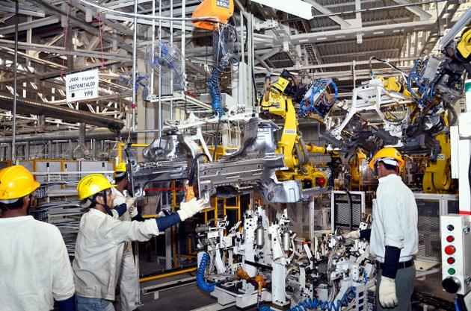](http://www.google.com.sa/url?sa=i&rct=j&q=&esrc=s&frm=1&source=images&cd=&cad=rja&docid=PuBcYie8GKNcnM&tbnid=7BLBt1BIqJHUfM:&ved=0CAUQjRw&url=http%3A%2F%2Fmechstuds.com%2F%3Ftag%3Dmechanical-engineering&ei=HKpFUbK3A8jYPKj-gbAO&psig=AFQjCNHibJ8wC0-lYQkd0LCY2DiD309v4Q&ust=1363606418985013)

Mechanical Engineer